26th June 2020

Login to practice lab –

Login - ragavendrababug

Password - ababug0A@6ihar

Link - <https://ragavendrababug.centralus.cloudapp.azure.com:42001/guacamole/?username=guacadmin&password=guacadmin>

Install Java as a pre-requisite for Jenkins. Install GIT also.

Jenkins support for windows - <https://wiki.jenkins.io/display/JENKINS/Thanks+for+using+Windows+Installer>

Community group - <https://community.simplilearn.com/threads/devops-jun-27-to-jul-26-saurabh.52520/>

GIT login -

Ragavendra78

Del&sym5_12

Need of version control -

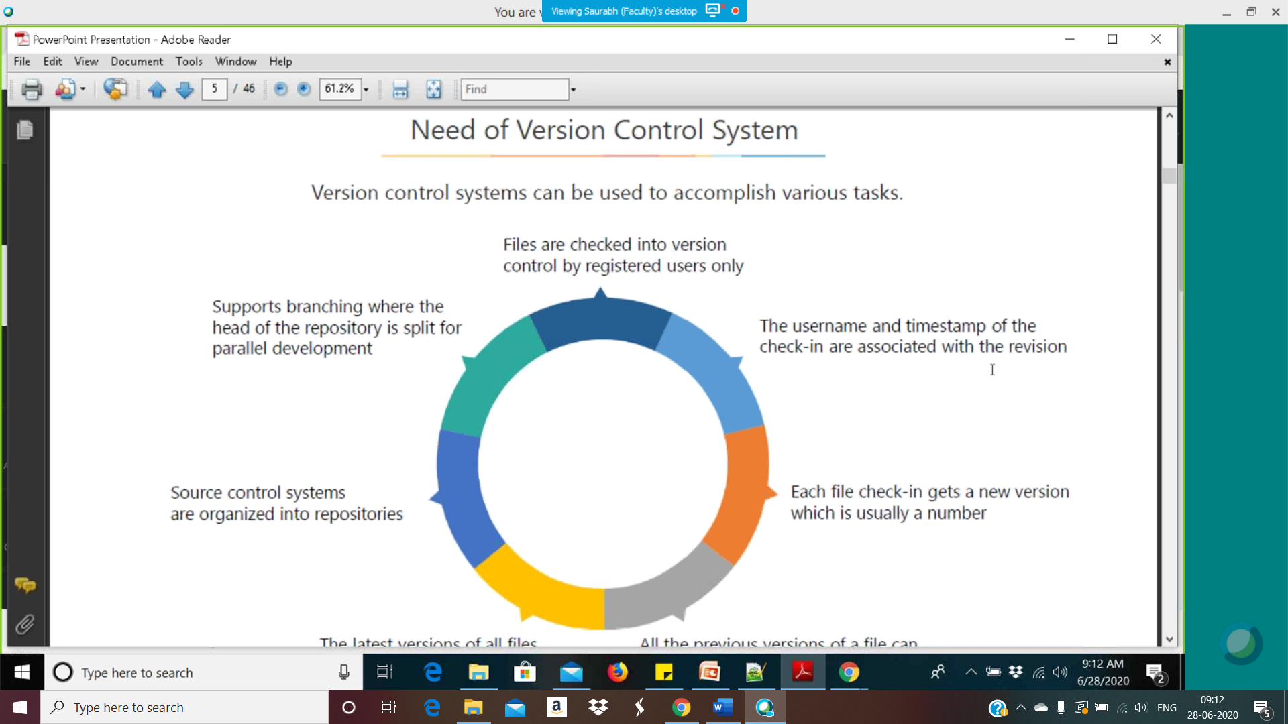

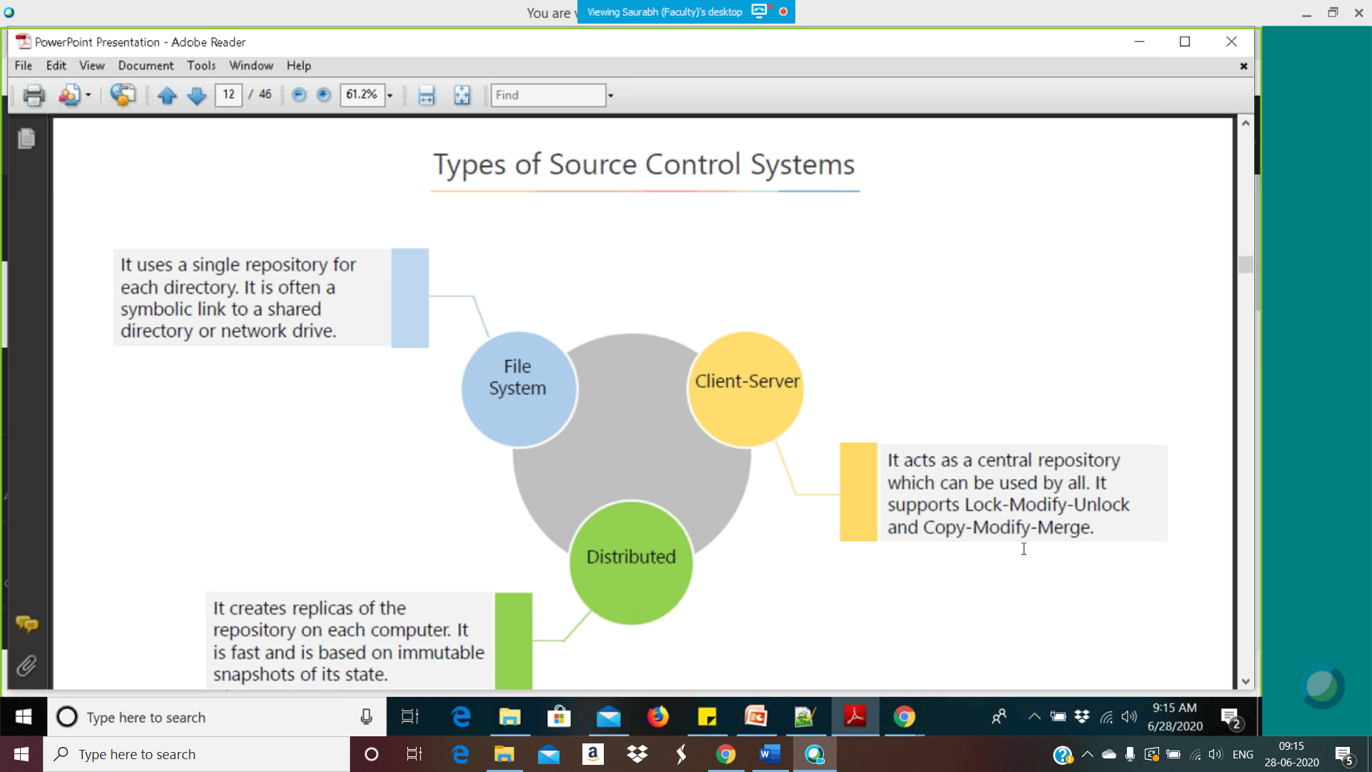

* File system source control is just like sharing windows folders with anybody.
* Client Server is central repository with access to members. One member can do access and for other members will be locket. E.g. SharePoint checkin on excel or word files.
* Distributed – creates copy for each user on their machine. See below pic.

